Test Case: tc001_SPX_Dev5_Crear_Solicitud_Articulo_Almacen
Step 1 - Enter username and password and click to button Enter : Credentials Entered
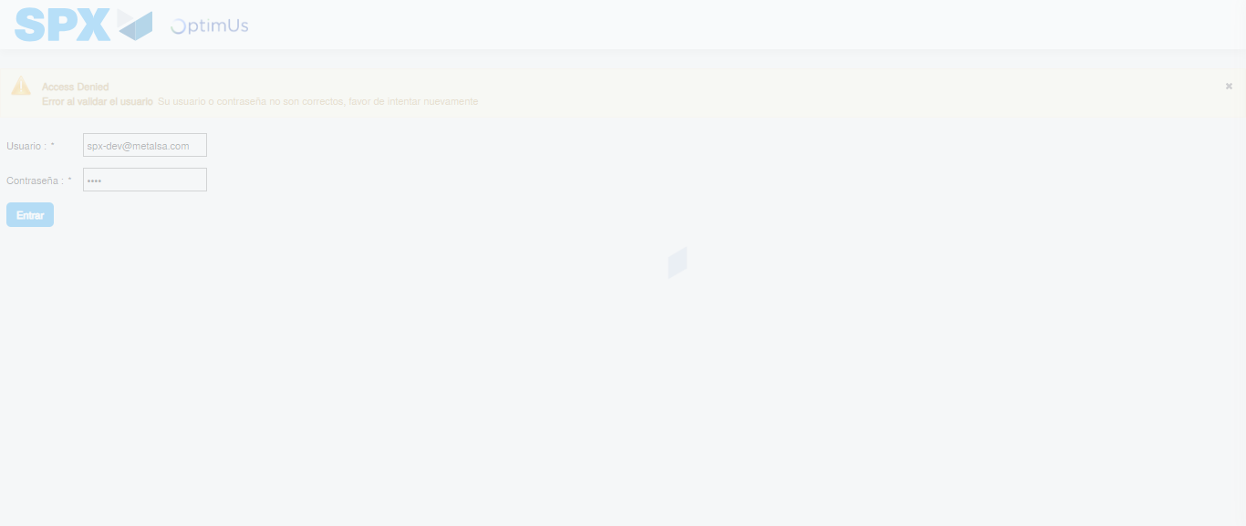Image file-name: QC_Testing-tc001_SPX_Dev5_Crear_Solicitud_Articulo_Almacen-1787933354678

Step 2 - Select to UEN and Access to Request for a New Inventory Item : UEN Correctly selected and Correct access
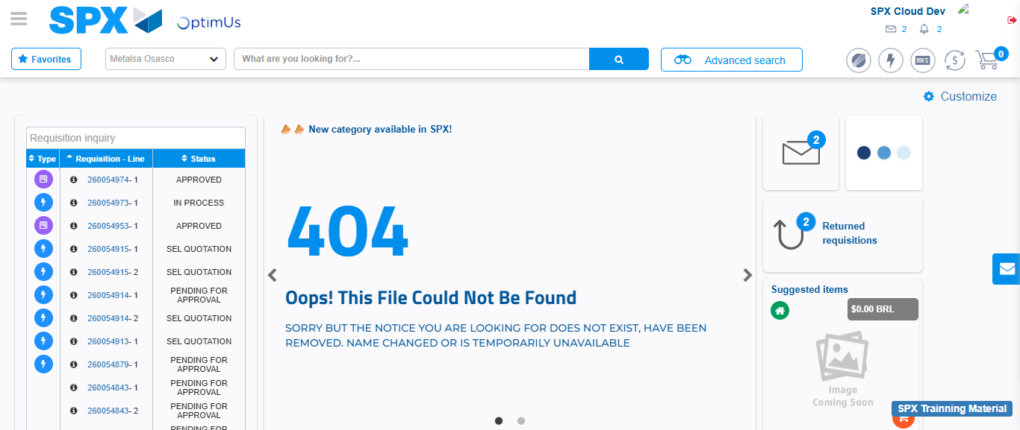Image file-name: QC_Testing-tc001_SPX_Dev5_Crear_Solicitud_Articulo_Almacen-1787933383731

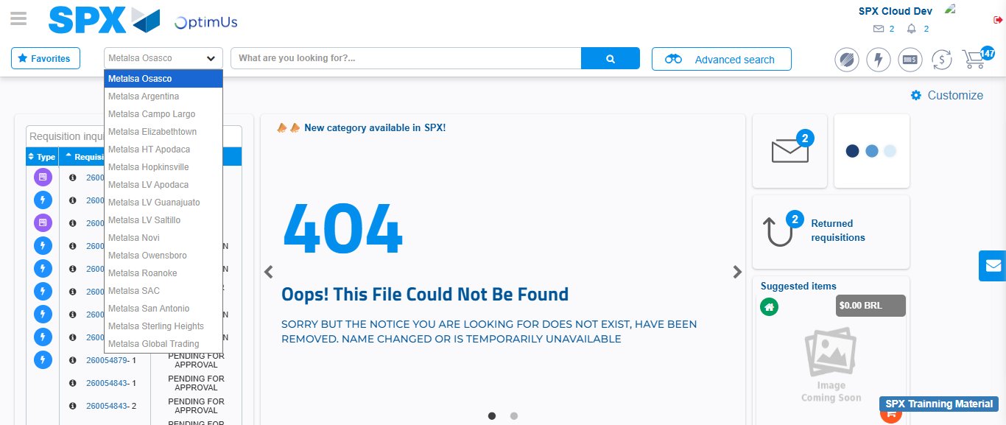Image file-name: QC_Testing-tc001_SPX_Dev5_Crear_Solicitud_Articulo_Almacen-1787933384558

Image file-name: QC_Testing-tc001_SPX_Dev5_Crear_Solicitud_Articulo_Almacen-1787933401860

Step 3 - Select options first section : Options seleted correctly
Image file-name: QC_Testing-tc001_SPX_Dev5_Crear_Solicitud_Articulo_Almacen-1787933402183

Image file-name: QC_Testing-tc001_SPX_Dev5_Crear_Solicitud_Articulo_Almacen-1787933402464

Step 4 - Select options at Screen: Options seleted correctly
Image file-name: QC_Testing-tc001_SPX_Dev5_Crear_Solicitud_Articulo_Almacen-1787933402183

Image file-name: QC_Testing-tc001_SPX_Dev5_Crear_Solicitud_Articulo_Almacen-1787933402464

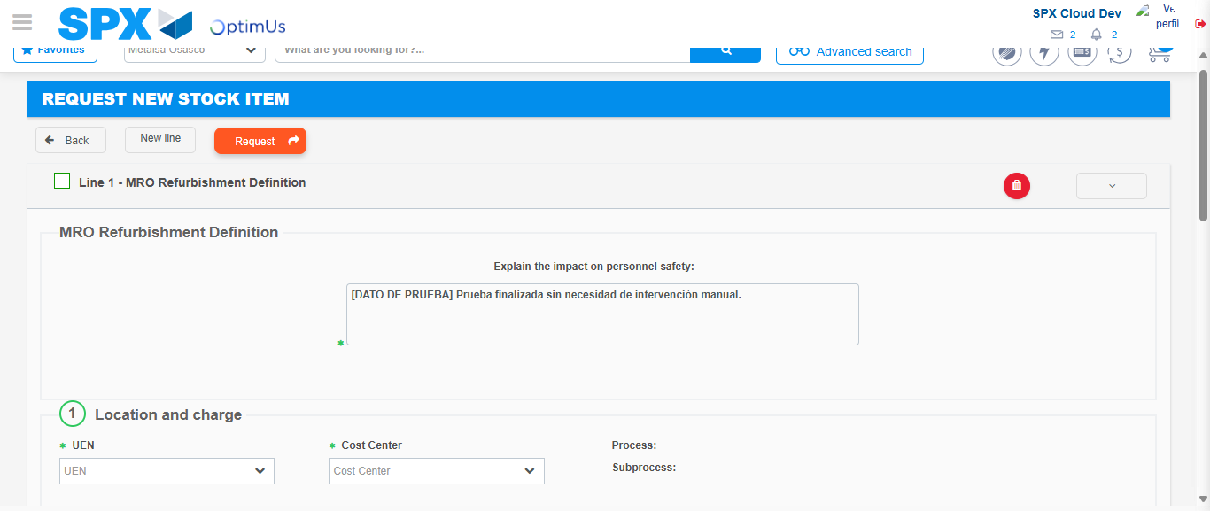Image file-name: QC_Testing-tc001_SPX_Dev5_Crear_Solicitud_Articulo_Almacen-1787933409646

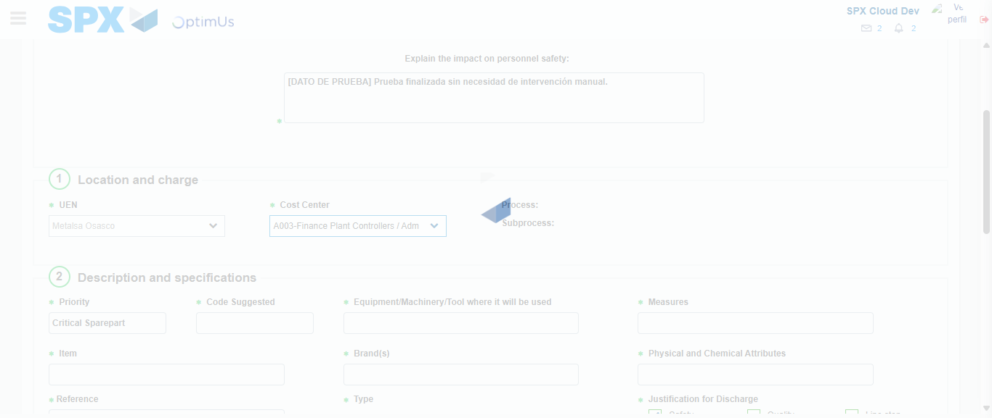Image file-name: QC_Testing-tc001_SPX_Dev5_Crear_Solicitud_Articulo_Almacen-1787933412968

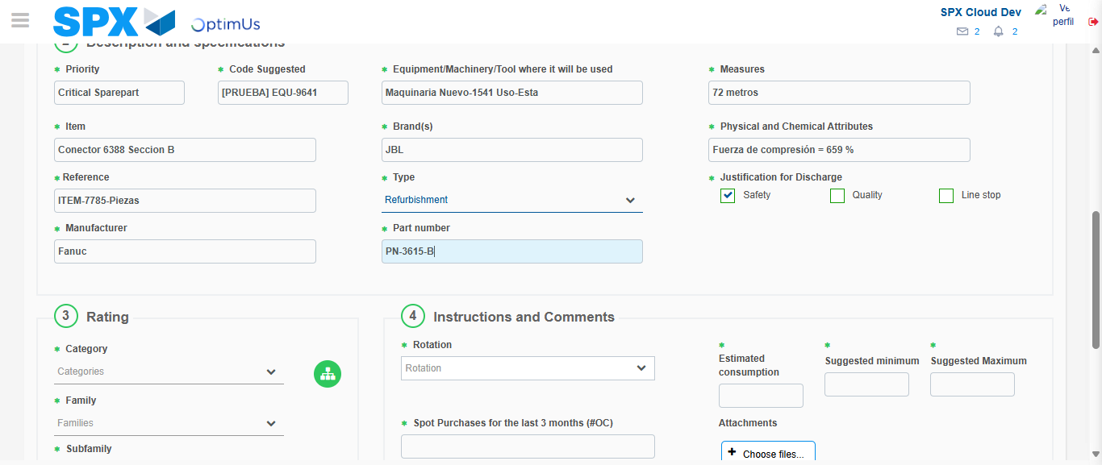Image file-name: QC_Testing-tc001_SPX_Dev5_Crear_Solicitud_Articulo_Almacen-1787933415521

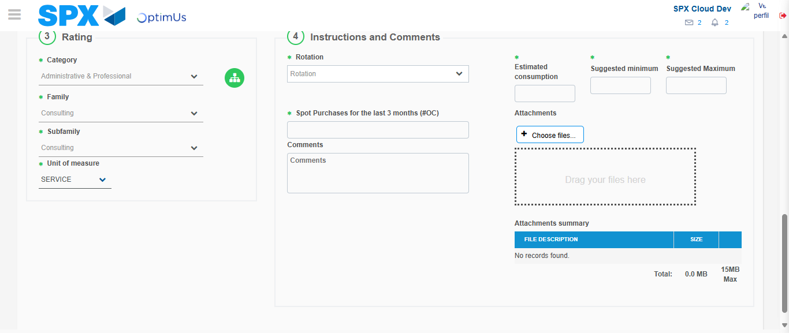Image file-name: QC_Testing-tc001_SPX_Dev5_Crear_Solicitud_Articulo_Almacen-1787933420997

Step 5 - Request New Item : Request Accepted
Image file-name: QC_Testing-tc001_SPX_Dev5_Crear_Solicitud_Articulo_Almacen-1787933383731

Image file-name: QC_Testing-tc001_SPX_Dev5_Crear_Solicitud_Articulo_Almacen-1787933384558

Image file-name: QC_Testing-tc001_SPX_Dev5_Crear_Solicitud_Articulo_Almacen-1787933401860

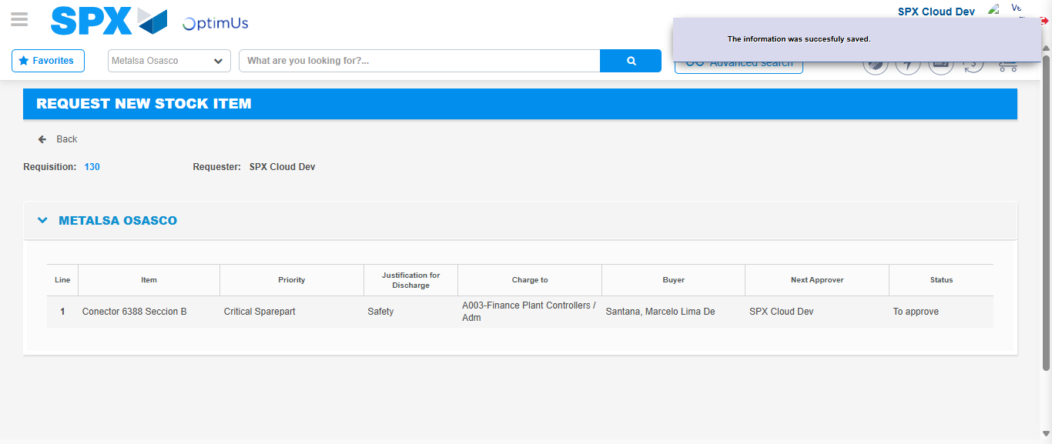Image file-name: QC_Testing-tc001_SPX_Dev5_Crear_Solicitud_Articulo_Almacen-1787933429322

Image file-name: QC_Testing-tc001_SPX_Dev5_Crear_Solicitud_Articulo_Almacen-1787933429575

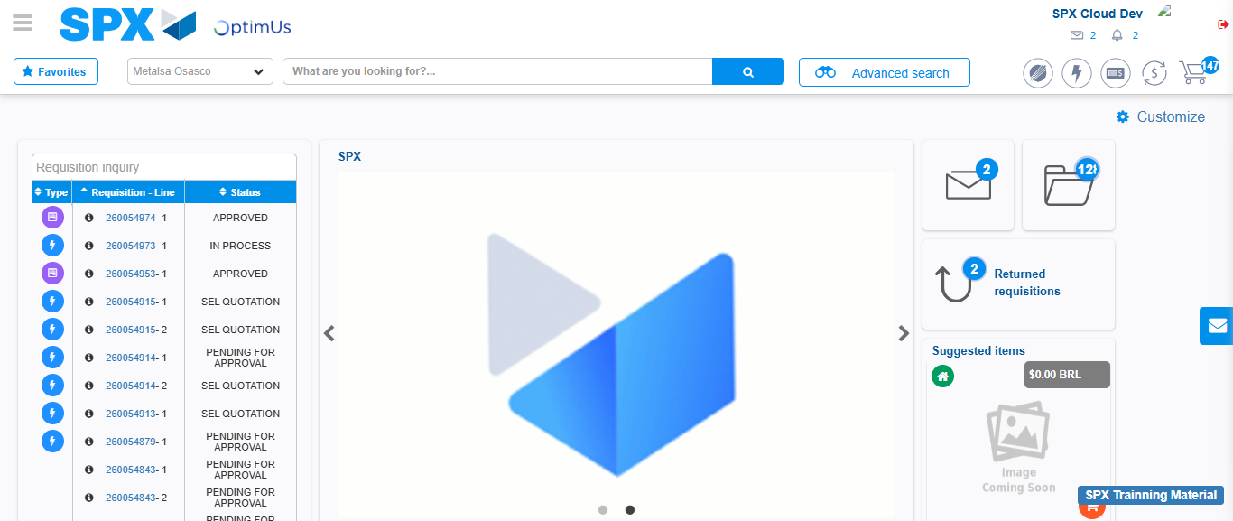Image file-name: QC_Testing-tc001_SPX_Dev5_Crear_Solicitud_Articulo_Almacen-1787933451363

Step 7 - Return to Main Page SPX : Return to Main Page SPX
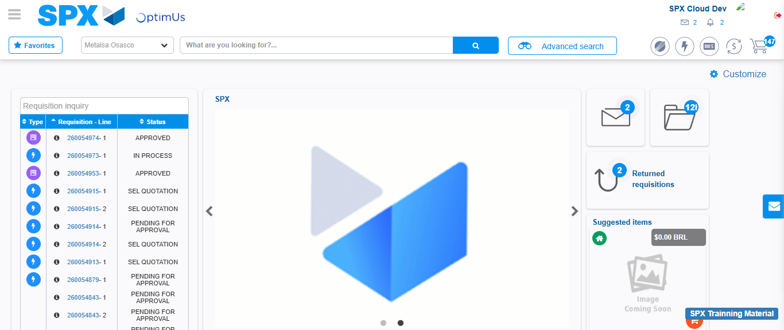Image file-name: QC_Testing-tc001_SPX_Dev5_Crear_Solicitud_Articulo_Almacen-1787933451747

